



**SM6P07NI Digital Media Project**

**20% Report**

**2025-26 Spring**

**Student Name: Sanket Shrestha**

**London Met ID: 22067428**

**College ID: NP01MM4A220103**

**External Supervisor: Rupesh Dangol**

**Internal Supervisor Parwat Bhujel**

**Assignment Due Date: Sunday, May 4, 2025**

**Assignment Submission Date: Wednesday, May 7, 2025**

**Word Count: 3418**

*I confirm that I understand my coursework needs to be submitted online via Google Classroom under the relevant module page before the deadline in order for my assignment to be accepted and marked. I am fully aware that late submissions will be treated as non-submission and a marks of zero will be awarded.*

**Abstract**

This project “SpaceChimp” requires a responsive and accessible website design which delivers educational courses on UI/UX design alongside motion graphics subjects. The documentation includes all designing stages beginning with planning until creating sitemaps and finishing with Figma-based high-fidelity prototype design and wireframing. Stark and similar tools helped ensure accessibility throughout the design phase while the website's visual components including colors and typography together with components established a clear and unified brand image. User surveys were implemented at the site to collect opinions on design aspects and functionality and usability.

**Contents**

1 Introduction 1

1.1 Topic 2

1.2 Area of Research 3

1.2.1 Responsive, Adaptive, and Accessible Design Principles 3

1.2.2 Competitor Analysis 4

1.2.3 UI/UX Design for Educational Engagement 4

2 Aims of Project 5

3 Target Audience 6

4 Product Research 8

4.1 Broadway Infosys: 8

4.2 Skillshare: 9

5 Technologies Employed 10

5.1 Figma 10

5.2 Figma Plugins 10

5.3 Browser Developer Tools using Google Inspect Element. 12

6 Project Plan 13

7 Production Phases 15

7.1 Research & Discovery 15

7.2 Sitemap 16

7.3 Wireframing (Low-Fidelity Design) 18

7.4 Accessibility & Colour Evaluation 19

7.5 Style Scape & Component System 21

7.6 High-Fidelity Design 23

7.7 Prototyping & Micro Interactions 27

8 Resources 28

9 User Testing & Findings 29

10 Conclusion 38

11 Bibliography 39

12 Appendix 40

**Table of Figures**

Figure 1 Responsive and Adaptive Web Design (Interaction Design Foundation, n.d.). 3

Figure 2: Hero Section of Broadways Infosys 8

Figure 3: Class Content of Skill Share 9

Figure 4: Figma Logo Mark 10

Figure 5: Stark Logo 10

Figure 6: Material Symbols Logo 11

Figure 7: Iconoir Logo 11

Figure 8: Google Inspect Element Technique 12

Figure 9: Initial Gantt chart 13

Figure 10: Final Gantt Chart 14

Figure 11: Notion Bookmarks 16

Figure 12: SpaceChimp Sitemap 17

Figure 13: Low-Fi Wireframe 18

Figure 14: Colour Contrast Checking of a Tag 19

Figure 15: Font Size Checking for Accessibility 20

Figure 16: Style Guide for Typography (All Screens) 21

Figure 17: Style guide for Color Palette 22

Figure 18: Components 22

Figure 19: Home Page Hero Section (Desktop, Mobile, and Tablet) 23

Figure 20: About Page Hero Section (Desktop, Mobile, and Tablet) 24

Figure 21: Courses Page Hero Section (Desktop, Mobile, and Tablet) 24

Figure 22: Course Detail Page Hero Section (Desktop, Mobile, and Tablet) 25

Figure 23: Teacher Page Hero Section (Desktop, Mobile, and Tablet) 25

Figure 24: Contact Page Hero Section (Desktop, Mobile, and Tablet) 26

Figure 25: Enrolment Page Hero Section (Desktop, Mobile, and Tablet) 26

Figure 26: Prototyping 27

Figure 27: Animation 27

Figure 28: QA Result 1 30

Figure 29: QA Result 2 30

Figure 30: QA Result 3 31

Figure 31: QA Result 4 32

Figure 32: QA Result 5 33

Figure 33: QA Result 6 34

Figure 34: QA Result 7 36

Figure 35: QA Result 8 37

Figure 36: Gantt Chart 40

# Introduction

The assessment method controls the evaluation process for student work throughout digital media project development. Throughout this coursework students receive evaluative feedback on their initial project ideas together with a research-based written analysis and reflective assessment of the production steps. Students will learn how to implement design and production techniques in digital media development while effectively analyzing project growth together with final outcome assessment.

This project is about website design for “SpaceChimp”. SpaceChimp is an educational platform which delivers UI/UX design and motion graphics and digital skill training to learners. The platform seeks to deliver educational materials by showcasing their expertise through web experience that is interactive and easy to navigate. This project investigates how effective interface design along with strategic typography decisions alongside proper layout structure and motion elements will improve user experience and develop a strong brand image for educational design-focused platforms. Figma served as the platform for designing the UI/UX elements and handling the motion prototyping the project goes alongside design research and user testing constituted part of the project requirements.

## Topic

SpaceChimp is a digital educational platform to provide first-class design and develop courses which serves as the primary subject of this project. The three courses available through SpaceChimp include UI/UX Design together with Motion Graphics and Figma/Framer Design. SpaceChimp targets Nepalese learners to offer contemporary learning techniques and a visually appealing website interface with easy-to-use navigation. Every course receives instruction from experts who design the curriculum to develop occupation-ready creative skills for students.

## Area of Research

The core research component of this project revolved around the following question:

"**How can responsive, adaptive, and accessible design collectively improve user engagement and inclusivity on educational websites?** "

The research for SpaceChimp is divided into three main sections to analyze this core question.

### Responsive, Adaptive, and Accessible Design Principles

The research centered on responsive and adaptive design features and accessibility measures. Researchers studied methods to achieve consistent visual appearance on various devices and design methods to adjust layouts while implementing WCAG accessibility rules for diverse users. The research established four main areas involving flexible grids together with media queries followed by alt text and color contrast capabilities as well as keyboard navigation.

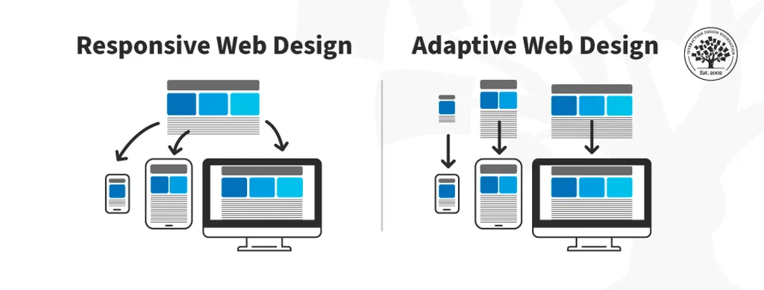

Figure 1 Responsive and Adaptive Web Design (Interaction Design Foundation, n.d.).

### Competitor Analysis

A review of platforms Broadway Infosys and Skill Share revealed important insights about user engagement along with content layout and accessibility and course presentation and animations. First-time users received special emphasis along with easy navigation improvements.

### UI/UX Design for Educational Engagement

Learning was examined through an investigation of design elements during this project. The analysis of layouts and animations combined with visual hierarchy optimized user flow, focus and brand identity while building an engaging learning experience.

# Aims of Project

This initiative studies how joint application of adaptive and accessible design elements boost educational website inclusivity alongside user engagement through the creation of SpaceChimp as a digital learning platform dedicated to UI/UX Design and Motion Graphics as well as Figma/Framer Design education.

The website development goal is to deliver an attractive platform with simple navigation which provides top-quality design education opportunities to Nepalese learners. Fluid design layouts form the foundation of this project together with adaptable components which adjust to different user needs and devices and accessible features that accommodate visual and motor disabilities.

The project also focuses on:

* A brand identity based on creative yet professional values is important for business success.
* The system features an easy-to-use navigation system with user-friendly actions for first-time users to access.
* The learning process becomes engaging and modern through interactive elements integrated with animations.
* The application relies on clear color selection in addition to exact typographical elements and space management to create better visual organization.
* The platform functions as an entry point which connects design learners as well as professionals to systematic educational content.

The SpaceChimp platform functions as a dual educational and inspirational system designed to build a diverse learning environment for Nepali creative minds of the next generation.

# Target Audience

SpaceChimp focuses on delivering its services to Nepal-based users who specialize in creative and digital design. SpaceChimp features capabilities that support the following aspects:

* **Age Group: 16–30 years:** The target group consists of people who hold high school diplomas together with university students and early professionals who need to enhance their UI/UX design abilities and motion graphic abilities while using Figma/Framer tools.
* **Gender: All Genders:** Through its approach SpaceChimp creates a space where members from any gender background can discover identical learning chances.
* **Ethnicity & Cultural Background: Primarily Nepali, but inclusive of all backgrounds:** The design philosophy stays loyal to Nepali cultural preferences but also follows universal industry standards to gain acceptability among diverse populations.
* **Location: Urban and semi-urban areas of Nepal:** The platform delivers optimized educational content through devices connected to the internet targeting individuals who live in Kathmandu Pokhara and Lalitpur because digital career interest is rapidly growing in those places.

**Why This Audience?**

* Young Nepali professionals along with students continue to seek digital design capabilities due to advancing IT and media sectors and freelance industries in Nepal.
* SpaceChimp provides invaluable services to numerous students who learned through self-study or lack sufficient resources because it provides an affordable structured learning platform that is accessible via the internet.
* These digitally savvy urban youth commonly use social media platforms which makes them attracted to visually interesting and interactive platforms for learning.
* The specific user group design approach ensures that content selection and layout structure undergo changes to match their usage patterns thus producing enhanced user engagement results.

# Product Research

## Broadway Infosys:

The website layout of Broadway Infosys maintains organized content and displays strong call-to-action buttons. The course highlights coupled with straightforward navigation found in SpaceChimp appear similarly throughout homepage and course pages.

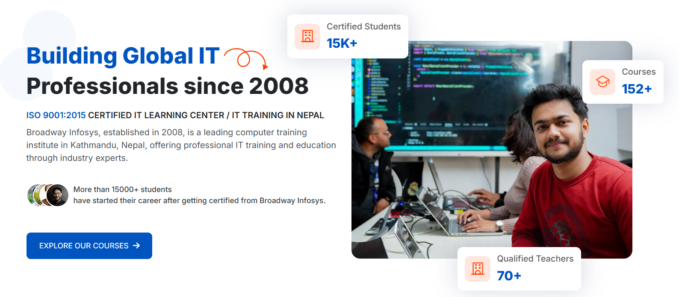

Figure 2: Hero Section of Broadways Infosys

## Skillshare:

Skillshare creates an interactive experience which features orderly typography alongside uniform color schemes. The structured course table of contents at SpaceChimp aimed to enhance the learner's understanding and navigation through the learning path.

Figure 3: Class Content of Skill Share

The analysis provided guidance for SpaceChimp's visual presentation together with user accessibility features and involvement mechanics.

# Technologies Employed

Several software tools along with design methodologies along with development techniques were incorporated through the SpaceChimp project development phase to create an accessible responsive educational website.

## Figma

The main tool for building low-fidelity wireframes together with high-fidelity UI designs and interactive prototypes along with animations was Figma. The software environment enabled designers to conduct quick iterative processes along with obtaining quick design feedback.

Figure 4: Figma Logo Mark

## Figma Plugins

The Stark plugin evaluated color contrast levels to achieve WCAG standards throughout the platform interface.



Figure 5: Stark Logo

The platform relied on Material Symbols & Iconoir plugins which brought a collection of contemporary icons for achieving visual uniformity across the interface.



Figure 6: Material Symbols Logo



Figure 7: Iconoir Logo

## Browser Developer Tools using Google Inspect Element.

The Inspect Element function within Google Chrome was utilized frequently to check how responsive and adaptive features perform across different device screen dimensions. The developers used this tool to track professional sites that adjusted their visual appearance on desktop and mobile devices as well as tablets this technique has help quiet a lot to design mobile and tablet view.

Figure 8: Google Inspect Element Technique

These technologies alongside tools led to designing SpaceChimp using a user-first method that provides service to all audiences and adheres to present-day UI/UX standards.

# Project Plan

Initially the SpaceChimp project utilized a Gantt Chart to organize work into Research followed by Design then Testing followed by Monitoring and Review phases. Research followed by Design then Testing and the project finished with Monitoring & Review. Through this approach we could handle workflow tasks while meeting every deadline requirement.

**Timeline Comparison:**

**Initial Timeline:**

According to the Gantt Chart, the Design Phase would be finished on March 25. Testing and final revisions would then take place between late March and mid-April.

Figure 9: Initial Gantt chart

**Updated Timeline:**

Before the finished product satisfied research objectives and design standards, a schedule change was made to improve design excellence and user interactions.

Figure 10: Final Gantt Chart

The schedule modification demonstrates a new priority to enhance design quality along with user experience before tackling final optimization. An important adjustment became necessary in order to match the outcome with the principal research questions together with design benchmarks.

# Production Phases

The production of this project “SpaceChimp” was done in a structured and phased way to get the clarity, functionality, and user-cantered design. Below here are the steps that were followed for the production phase.

## Research & Discovery

This stage was focused on understanding the project context and goal. Research was done for targeted audiences and similar websites like Broadway Infosys and skill share. Which helped to gain knowledge how a educational websites function. Although the focus was to check how other educational websites are responsive, adaptive and how accessible is their websites.

Many other websites were observed for layouts and animations. Bookmarks of website that has been taken as inspiration were noted in notion.

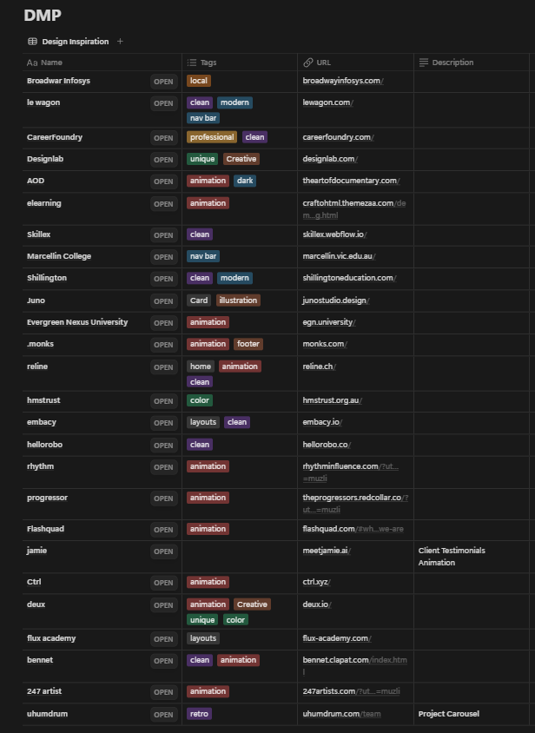

Figure 11: Notion Bookmarks

## Sitemap

Before designing the layouts, a simple sitemap was created to get a proper vision of what pages the website will have. The sitemap was created in Figma.

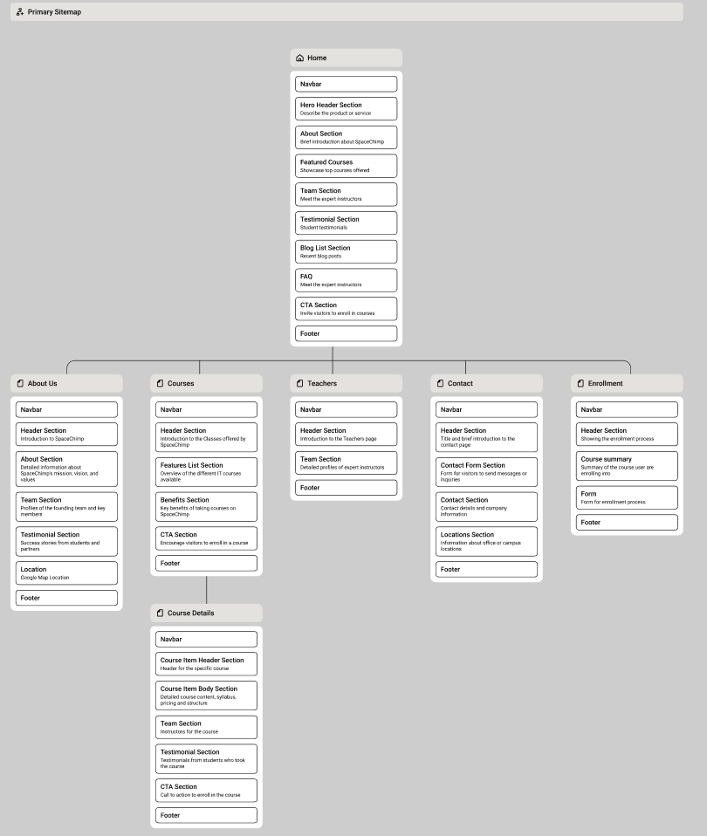

Figure 12: SpaceChimp Sitemap

## Wireframing (Low-Fidelity Design)

After creating the sitemap, low fi wireframe was made using Figma. The wireframe helped to visualize the content placement as well as user flow. Main focus has been on the structure and navigation rather than styling.

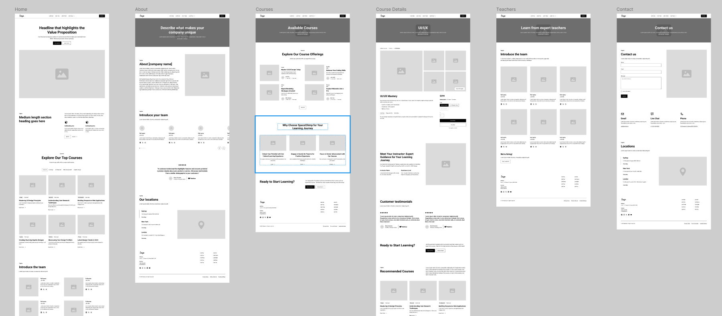

Figure 13: Low-Fi Wireframe

## Accessibility & Colour Evaluation

The client provided SpaceChimp's color palette, which was tested using the Stark plugin to ensure it met **WCAG accessibility standards**. The website required this feature to achieve readability and functionality for users with visual disabilities. Visual presentation quality was tested to improve accessibility throughout the website.

Figure 14: Colour Contrast Checking of a Tag

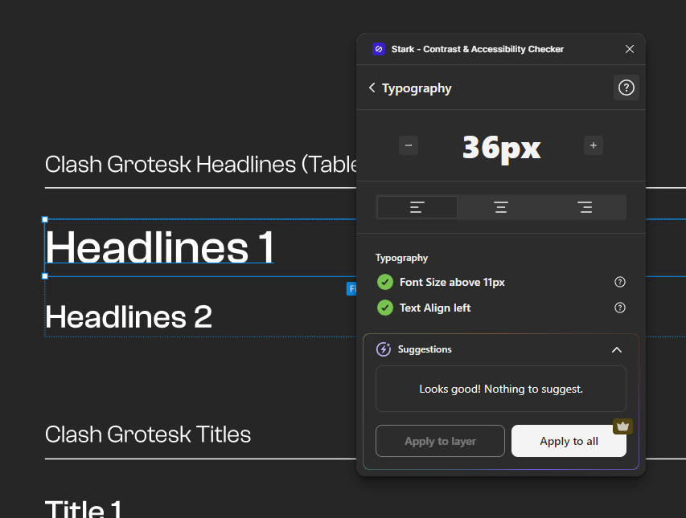

Figure 15: Font Size Checking for Accessibility

## Style guideline & Component System

Prior to developing the high-fidelity screens, Style guide was created in Figma to maintain the design consistency. This included:

* Typography: Primary and secondary fonts choices for headings, titles, body text, and CTAs.
* Colour Palette: Based on the client-provided colors, fine-tuned for readability and visual harmony.
* Component Library: Reusable UI components such as buttons, navigation bar, footer, etc., were built to maintain consistency and speed up the design process.

This phase has established consistent design standards that worked throughout all the website pages and on different screen resolutions.

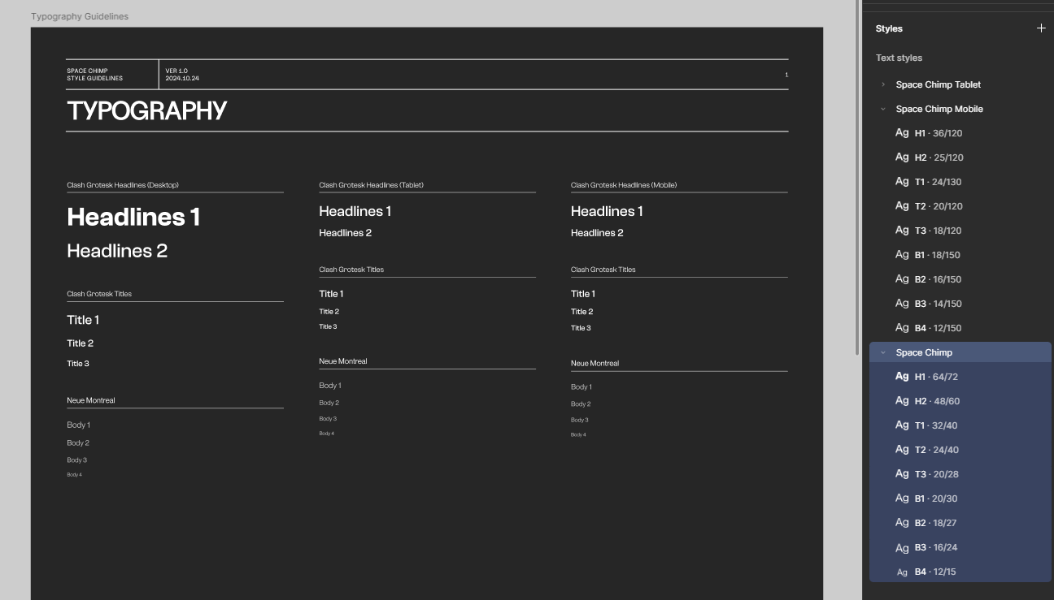

Figure 16: Style Guide for Typography (All Screens)

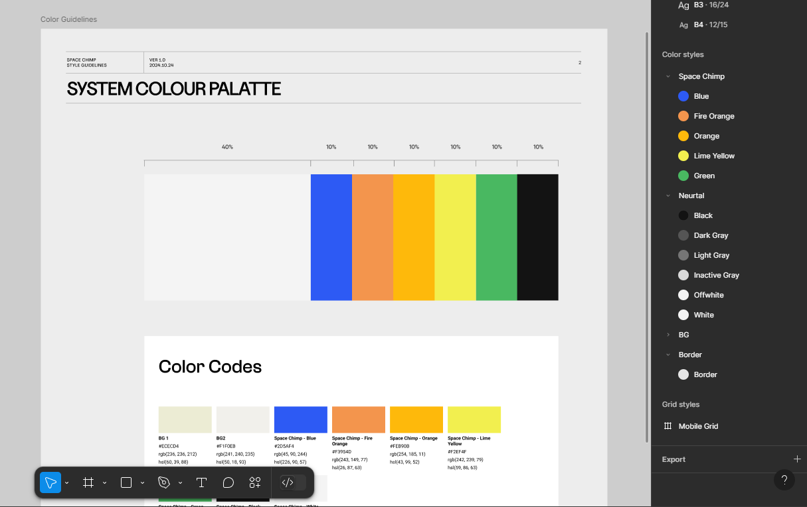

Figure 17: Style guide for Color Palette

Figure 18: Components

## High-Fidelity Design

Figma was used for designing the High-Fidelity Design. This process includes the implementation of brand colours, typography and managing the content hierarchy.

Figure 19: Home Page Hero Section (Desktop, Mobile, and Tablet)

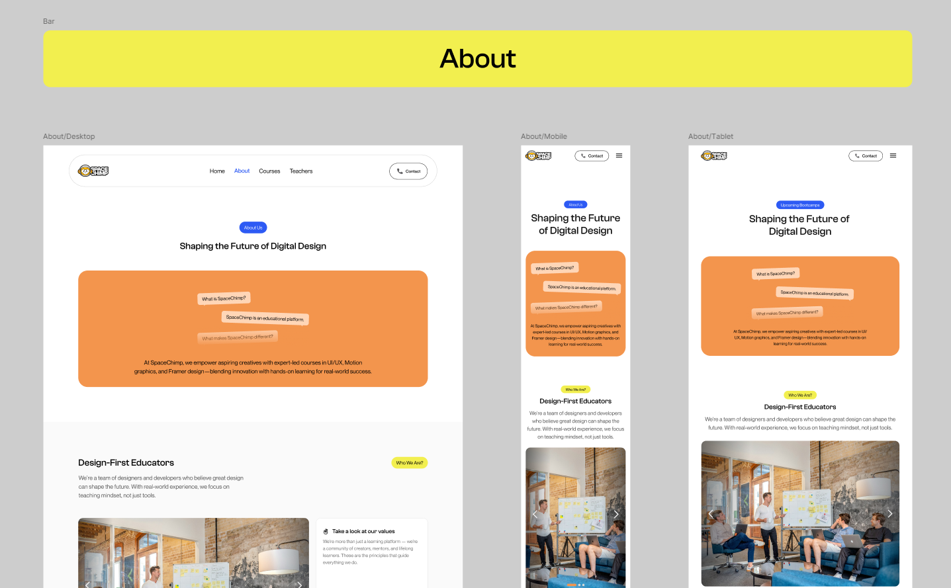

Figure 20: About Page Hero Section (Desktop, Mobile, and Tablet)

Figure 21: Courses Page Hero Section (Desktop, Mobile, and Tablet)

Figure 22: Course Detail Page Hero Section (Desktop, Mobile, and Tablet)

Figure 23: Teacher Page Hero Section (Desktop, Mobile, and Tablet)

Figure 24: Contact Page Hero Section (Desktop, Mobile, and Tablet)

Figure 25: Enrolment Page Hero Section (Desktop, Mobile, and Tablet)

## Prototyping & Micro Interactions

Prototyping has been done in Figma by navigating all the links and buttons to their right pages along with some simple animation to get a realistic feel of the final product. This prototyping has helped to do user testing and get early feedback for refinements.

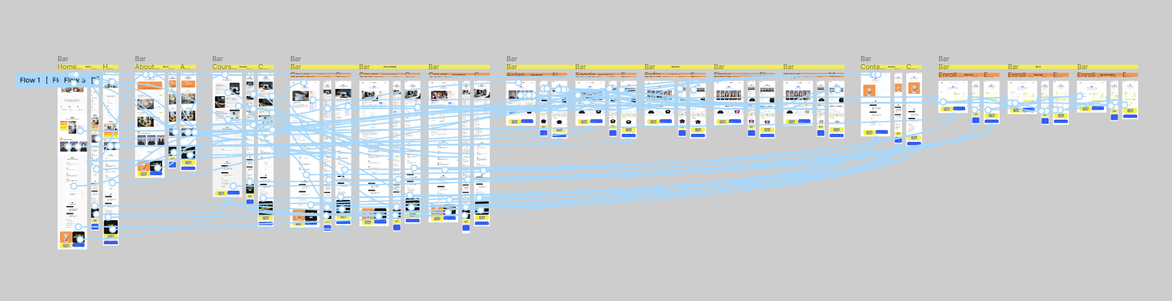

Figure 26: Prototyping

Figure 27: Animation

# Resources

All necessary hardware devices and software systems were applied throughout design development and testing stages of the SpaceChimp project. The Google Inspect Element served as an additional tool past initial proposal specifications to test both responsiveness and accessibility of the product.

**Hardware Specifications:**

* Device: Lenovo Legion 5
* Graphics: NVIDIA GeForce GTX 1660 Ti
* Processor: AMD Ryzen 7 4800H with Radeon Graphics

**Software Tools:**

* The Figma platform serves multiple purposes which include designing elements from both low-fidelity wireframes and high-fidelity UI screens and building prototypes and animations alongside creating style guides.
* Google Forms was used as a platform to gather user testing feedback.

**Research and Testing Tools:**

* The Stark Plugin was used to conducted WCAG guideline-based evaluations of both text and color accessibility.
* Google Inspect Element (ChromeDev Tool): used to check the adaptively of other website in different screens

# User Testing & Findings

A user testing session was evaluated to test both the effectiveness and usability along visual look of the SpaceChimp website. The evaluation examined how the website design combined with user reception in addition to content readability and website functionality. Users performed tests with the deployed prototype and through an established Google Form questionnaire session.

Twenty participants from various demographic groups representing different industries along with diverse device orientations conducted the testing. A combination of demographic information and detailed questions about the user interface, visual design along with usability assessments were included in the questionnaire.

**The main areas of evaluation included:**

1. **Understanding the demographics of the participants**

* Participants aged 18–24 made up the majority of users at 55% while those under 18 represented 45% of the total sample.
* Males made up the largest participant group at 75% while others and females followed.
* Research participants represented three distinct fields where 50% were students within education alongside 35% who worked in creative and design and 15% pursued careers in tech development.
* Desktop devices were used by 55% of participants whereas 25% used mobile and 20% used tablet devices for their interactions.

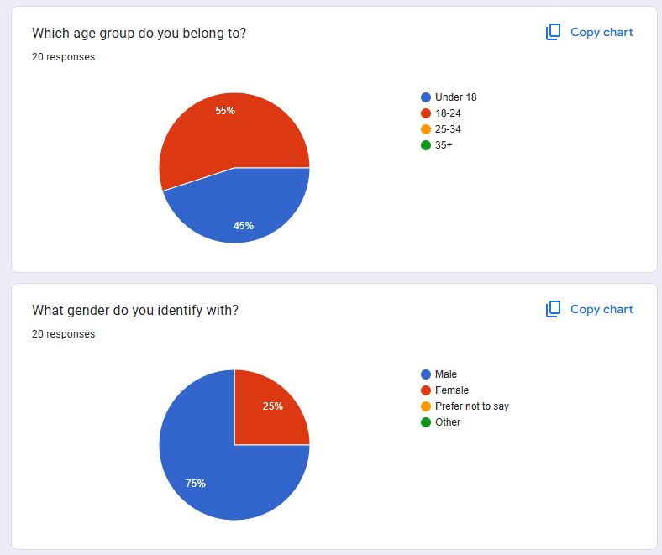

Figure 28: QA Result 1

Figure 29: QA Result 2

1. **Initial impression of the landing page**

* Participants responded positively to the homepage design:
* The website's first glance received strong positive feedback from 75% and received neutral reactions from the remainder.
* The homepage effectively communicated organizational purpose according to 85% of respondents even though a couple said it had unclear messaging.

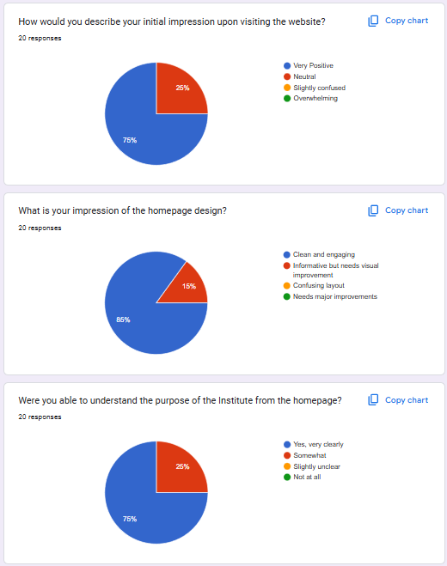

Figure 30: QA Result 3

1. **Analysis of navigation and usability across the website**

* Users found navigating the website simple 85% of the time even though some believed it needed improvements.
* Page loading and elementialization provoked no issues for 90% of users yet minor obstructions were recorded by 15%.
* A significant number of users (85%) found the website's contact form easy to use.
* The participants graded the website navigation system mostly between 8–10 points on a navigation ease scale.

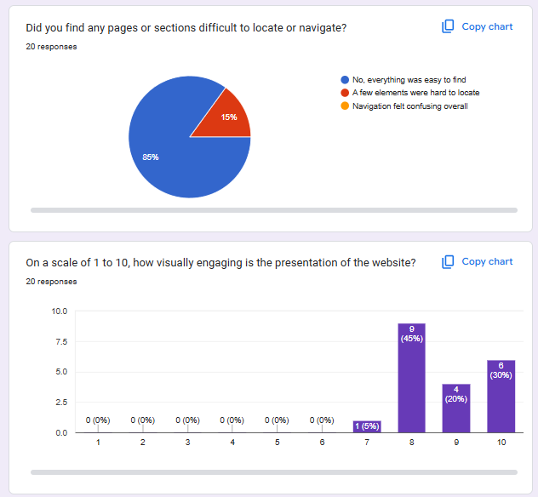

Figure 31: QA Result 4

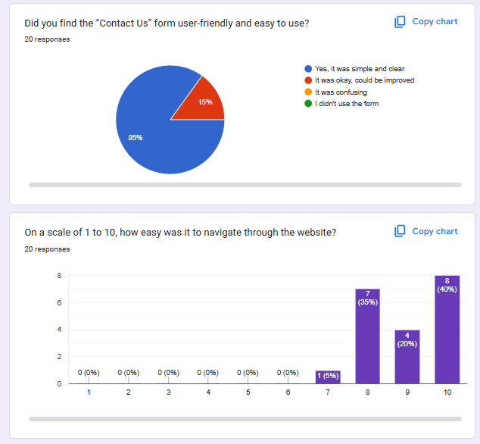

Figure 32: QA Result 5

1. **Evaluation of Typography and Brand Identity**

* Typography received high praise: The majority of users rated the design at least 8 out of 10 while 40% awarded it a perfect score of 10 out of 10.
* According to respondents a strong brand identity emerges from the powerful combination of visual elements which includes color, typography and visual design by 75% of the study participants.
* Participants showed strong agreement regarding the integration of elements where 70% assigned ratings of 9 or 10 points.

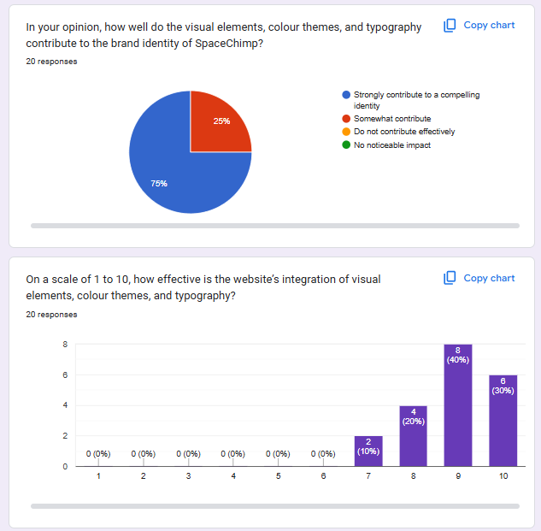

Figure 33: QA Result 6

**5. Overall effectiveness, technical stability, and areas of improvement**

* The survey results showed that 90% of users faced no technical problems but several users detected small software errors.
* Eighty percent of users stated they found all necessary website features present but some users wanted additional functionality.
* When asked about overall usability and functionality:
* The satisfaction rating felt by users was high with 85% assigning a score of ten.
* A large proportion of 65% expressed their strong willingness to recommend this resource to others.
* A majority of respondents (70%) praised the website's design quality including aesthetics and functionality alongside others who rated it good or fair.
* The design functioned adequately across different screen sizes pleasing 80% of users but certain users observed minor concerns on tablet and mobile screens.
* A screenshot of a computer

  AI-generated content may be incorrect.

Figure 34: QA Result 7

Figure 35: QA Result 8

**Summary**

Data received from testing shows the visual identity of the brand maintains its strength while ensuring consistent branding along with good response to adaptability of the website. The brand's visual identity has been validated by feedback as strong and consistent. Future versions will embrace minor suggestions for design improvements with new features added to the platform.

# Conclusion

The SpaceChimp project fulfilled all stated milestones while successfully solving the question about enhancing user involvement through flexible interactive design. Prototyping through Figma and Stark accessibility tools and use of browser development tools supported the completion of all phases from research to design. A consistent design system persisted through the implementation of stylescapes and sitemaps. The final prototype successfully showcased the SpaceChimp brand to users who provided encouraging feedback while meeting every specification requirement.

# Bibliography

*Interaction Design Foundation*. (n.d.). Retrieved from https://www.interaction-design.org/literature/article/should-you-choose-between-responsive-and-adaptive-design

# Appendix

Figure 36: Gantt Chart



